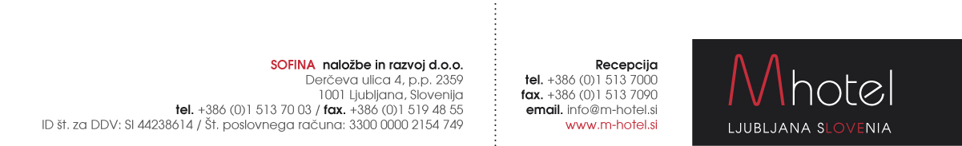

HOTEL RESERVATION FORM »Rocknroll & Boggie Woogie Ljubljana«
October 2016
Reservations to be sent to the following e-mail address: gregor.erbeznik@m-hotel.si
First and Last Name:
Club & Country
Phone/ fax number:
Email:
Arrival date:
Departure date:
Room type and number of persons:

RATES PER PERSON PER NIGHT:
Single room: | 75,00 EUR
Double/Twin room: | 45,00 EUR
Triple/ quad room | 40,00 EUR
Tourist tax: | 1,27€ per night

* Number of triple and quad rooms is very limited.

All the modern hotel rooms are comfort with, free Wi-Fi Internet, minibar, hairdryer, direct dial phone.
Very comfortable mattresses from the latoflex.

Payments: Payment to be made directly at the hotel.

Supplemet for half board (dinner or lunch): 9 €
Please write down on which date you would like to have it:

_________________________________________________

*RESERVATION IS ON REQUEST AND IS SUBJECT TO AVAILABILITY
* NUMBER OF ROOMS IS LIMITED

M hotel offers you a transfer service from/to the following airport:
Our taxi driver will be waitting for you at the arrival gate with an M hotel sign and your name on it.
Payment: directly to taxi driver.

IN CASE YOU NEED OUR TRANSFER SERVICE PLEASE FILL IN YOUR FLIGHT DETAILS:

ARRIVAL DATE:

ARRIVAL TIME:

FLIGHT NUMBER:

NUMBER OF PERSONS:

Welcome to M hotel! www.m-hotel.si

